Name: Class:

Task 1
Look at the following devices, some of which are robots. For each one, tick whether it has the following features that are needed for robots:
- A mechanical structure or framework
- Electrical components (such as sensors, microprocessors and actuators)
- Programmable
Also, make one tick to identify whether each row is a robot.
Device name | Image of device | Contains a mechanical structure / framework | Contains electrical components (sensors, microprocessors, actuators) | Is it programmable? | Is it a robot?
Ford Escort (1996) | 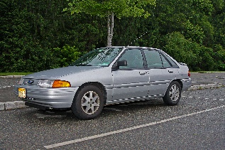
Self-driving delivery vehicles | 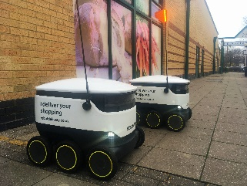
Lawn mower | 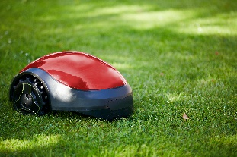
Robotic arm | 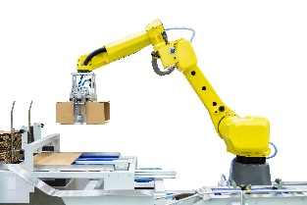
Lego® toy house | 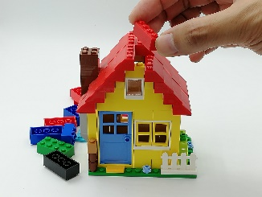
Mindstorms programmable Lego | 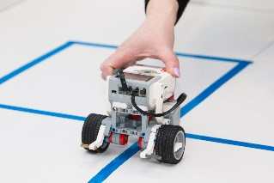
Bike delivery | 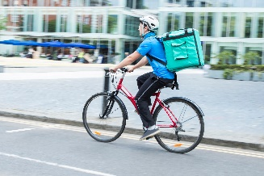

Task 2
Look at the following robot arm.

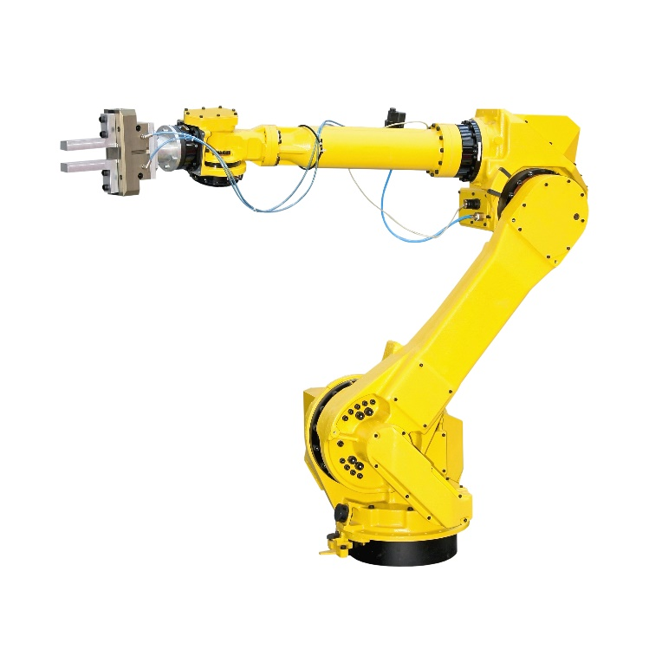

Identify seven actuators on the robot arm by circling or drawing arrows to them. Label each arrow between 1 and 7.
Discuss with a partner how the actuators can be moved so that the arm is able to grab an object on the table.

Task 3
Domestic robots include vacuum cleaners, lawn mowers and even robot kitchens.
(a) Research one of these robot types and make notes about how they work below.

(b) Feedback what you have learnt to the rest of the class.

Task 4
Robot buses have been in use in Finland since 2016. They work alongside ordinary buses, taking up to 12 passengers short distances without a driver.
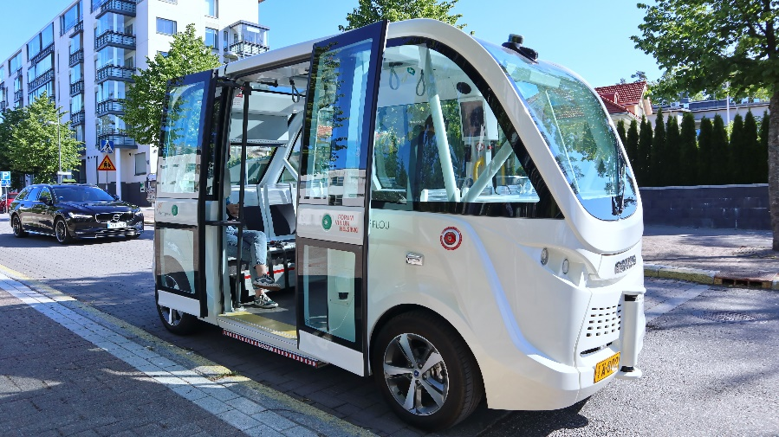
Discuss with a partner or in a small group the advantages and disadvantages of this type of robot.
Record your thoughts in the table below.
Advantages | Disadvantages

